**CAPTCHA**

**ACE BARANGAY MOBILE APPS**

**SUBMITED BY:**

**CABRERA, ELIZA M.  
DELOS POBRES, ARJAY  
MAMACLAY, CHRISTIAN U.**

**SUBMITED TO: MR. JOHN LEABRES**

1. **Description of the Project**

Image Captcha is used to limit service registration and captcha is used to prevent bots from spamming registration systems and creating fake accounts. It confirms to the service that the user is a real person, not a spam bot, and permits the user to continue to access the ACE Barangay. We choose this project because image-based captchas need both image recognition and semantic categorization, they are more difficult to interpret than text-based captchas. Captcha help our mobile apps to increase security. Also the Captcha is used to ensure that only humans are accessing a website. Our project helps to reduce spams and to prevent from being affected by brute force hacking attempts. Make our app safer.

1. **Applied Topic**

Captcha image -these captchas use graphical components that are easily recognized, such as animal photos, shapes, or scenery. Users must typically select images that match a theme or identify images that do not fit in image-based captchas. Captcha is a security feature that makes it difficult for an automated bot to run or log in to a website. The grid images are used to distinguish between bots and humans, as well as to prevent spam. We apply Captcha to our project the Captcha is used is Captchas are technologies that let you distinguish between real users and automated users like bots. Captcha provide challenges that are difficult for computers to perform but relatively easy for humans like recognizing and matching images.

1. **PLAN**

The plan that we will use in this capstone project is CAPTCHA to secure this project it’s a technique used by web services to differentiate between humans and bots. Most of these techniques are based on recognizing the distorted images that are often not easy to understand by the humans. We put forward a new idea of preventing automated attacks by bots, which asks users to pass through a simple two-step process of authentication. The first step involves recognizing an image from a set of images that best answers to the question associated with this step. The second step involves entering the values associated with the image selected so as to further nullify the probability of a bot attack. It helps to prevent fake registrations or sign-ups in application.

1. **Implement**

**Step 1**

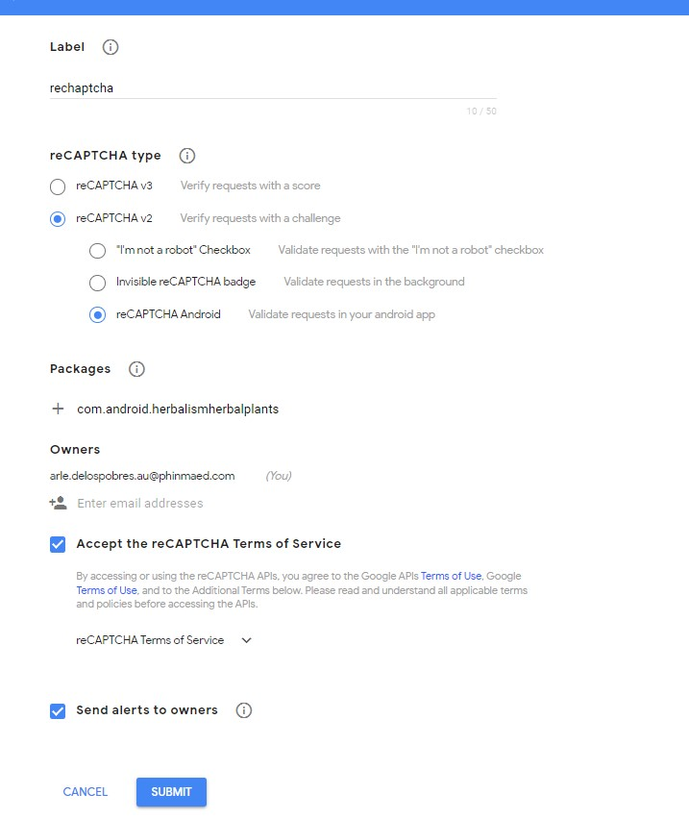

**Step 2**

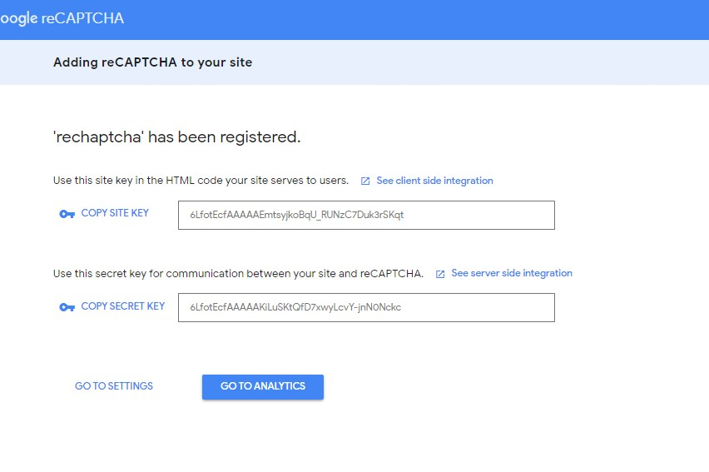

**Step 3**

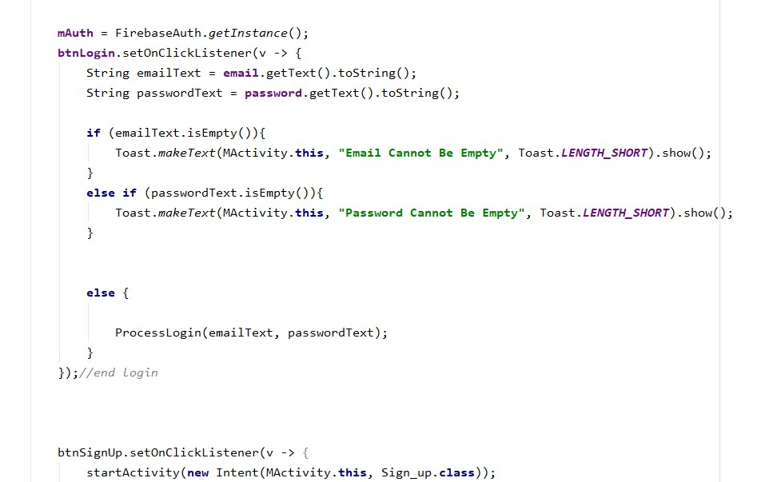

**Step 4**

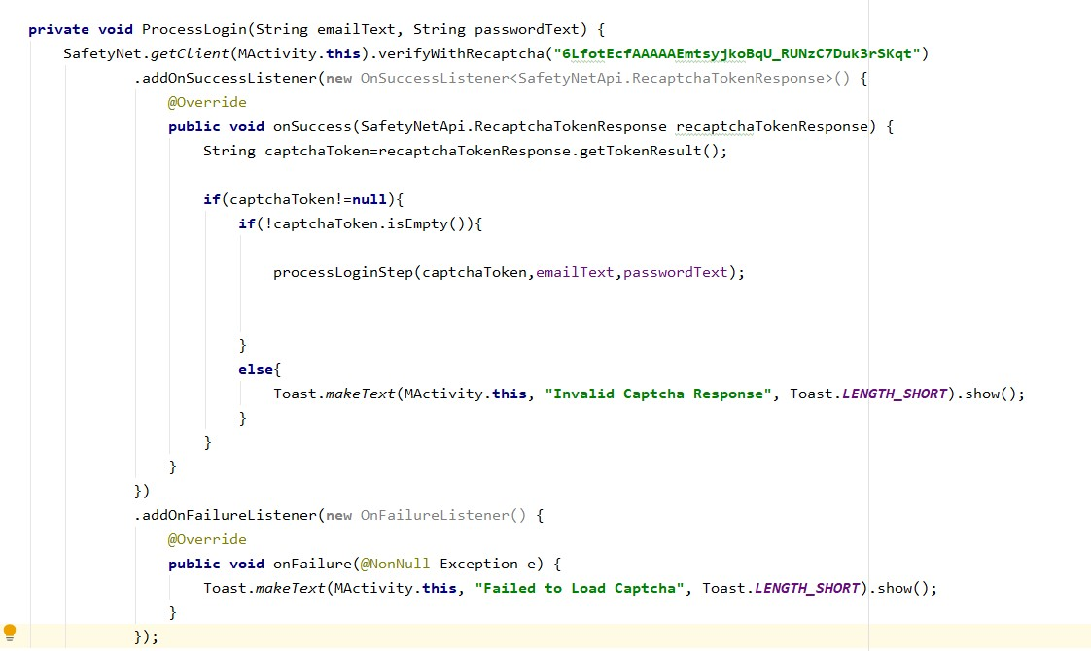

**Step 5**

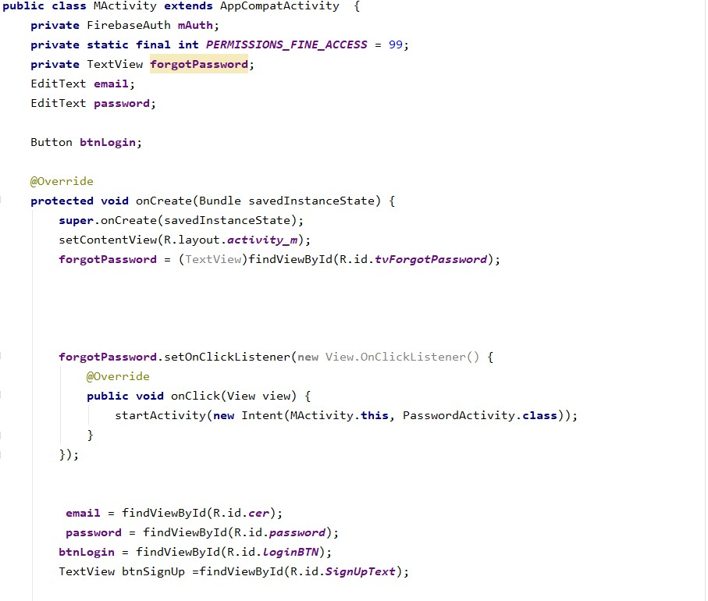

**Step 6**

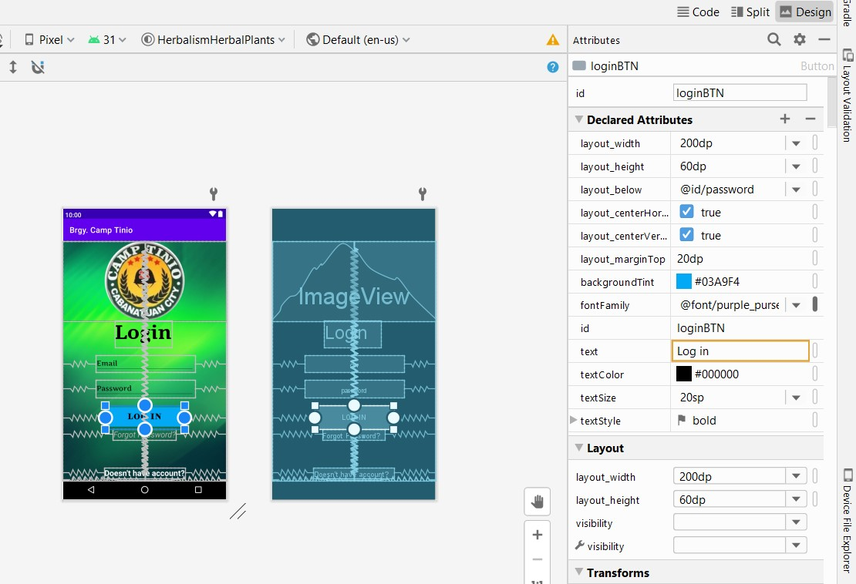

**Step 7-8**

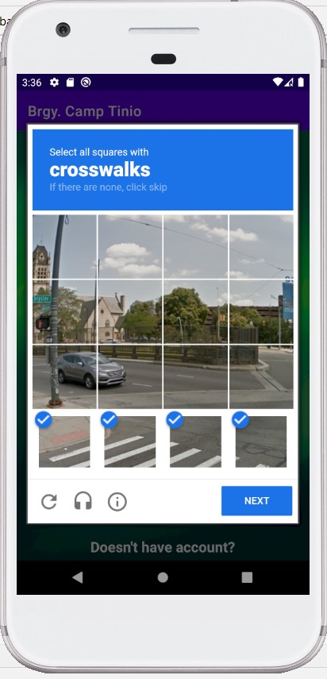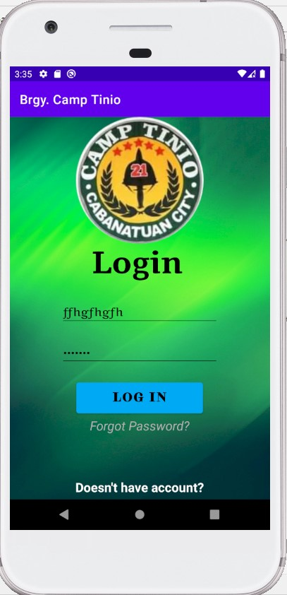

1. **RESULT**

This project provides the better security because some CAPTCHA images are difficult to interpret, human users are usually given the option to request a new CAPTCHA test.